Cognizant Foundry Platform
QA Test Results
Version No. 1.0



 | Prepared By / Last Updated By | Reviewed by | Approved By
Name | Srividhya Srinath
Role | Test Analyst
Signature
Date | 26-12-2016

User Stories
Story Id 124481821 –
As a System, in MySQL manual vertical scale-out needs to be implemented through REST service.

Test cases
MySQL Vertical Scale Out: (Dedicated Cluster Plan)
Verify whether user should able to create the service instance using Dedicated Cluster plan for MySQL
Verify whether user should able to see the VM in Bosh server
Verify whether user should able to do the scale out (increase the VMtype) for MySQLDB by using MySQL-service id in REST API call
Verify whether user should able to ensure the MySQLDB Scale out process using REST API

Acceptance Criteria
MySQL Vertical Scale Out: (Dedicated Cluster Plan)
User should able to create the service instance using dedicated single node Dedicated Cluster plan for MySQL
User should able to see the VM in Bosh server
User should able to do the scale out (increase the VMtype) for MySQL DB by using MySQL -service id in REST API call
User should able to ensure the MySQL DB Scale out process using REST API

Test Result
Pass

Defect / Open items
NA

Test Reference
MySQL Vertical Scale Out: (Dedicated Cluster Plan)
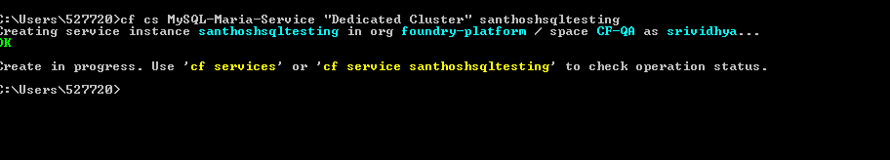
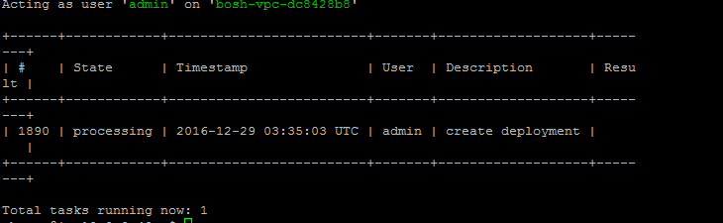
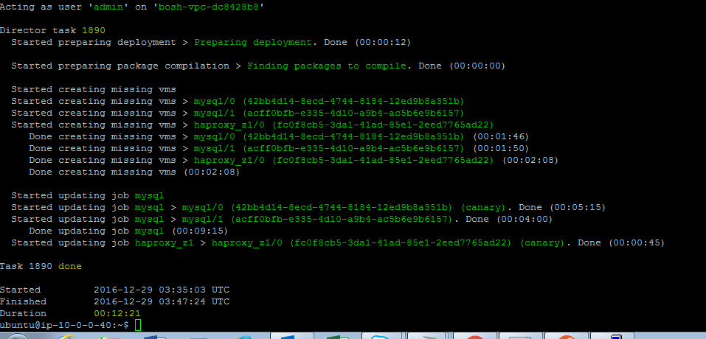
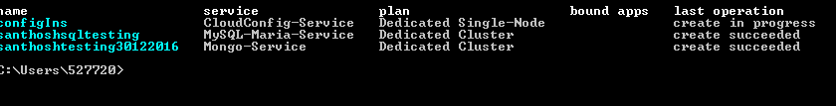
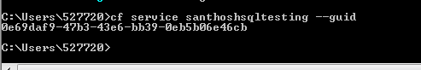
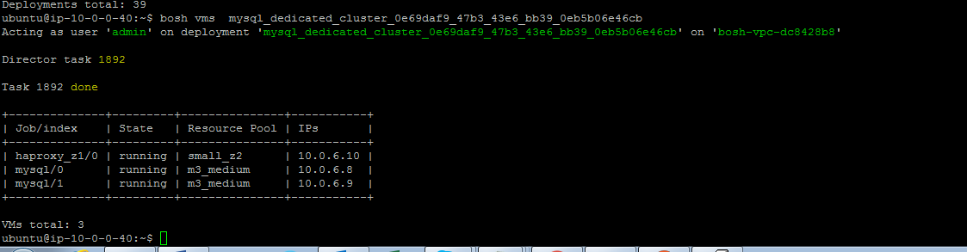
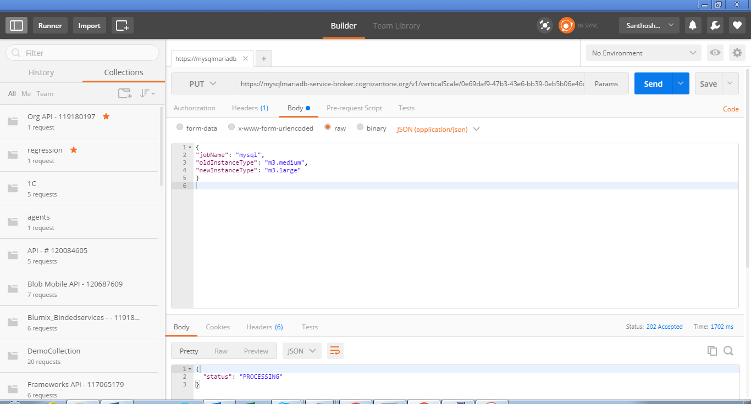
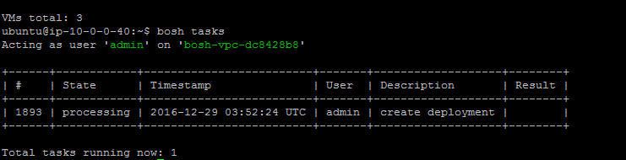
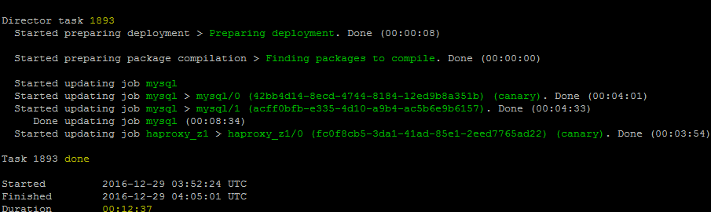
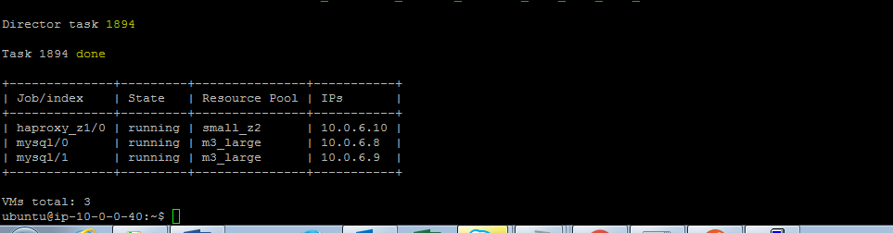

Change Log
Version Number | Changes Made
V1.0.0 | Initial baseline created on 26-12-16 by Srividhya
V1.1.0 | <Please refer the configuration control tool / change item status form if the details of changes are maintained separately. If not, the template given below needs to be followed>
V1.1.0 | Section No. | Changed By | Effective Date | Changes Effected

